
Name : Tahir Fareed
Roll No: SU92-BSAIM-F24-036
Program: BSAI (3-A)
Lab :11

Data saving and loading

Lab 11 Code Explanation

Code Cell 1
# !pip install pandas
import pandas as pd
import numpy as np
from sklearn.preprocessing import LabelEncoder
Explanation: This code cell loads libraries, reads dataset, or performs operations depending on its content.

Code Cell 2
df = pd.read_csv("used_cars.csv")
df

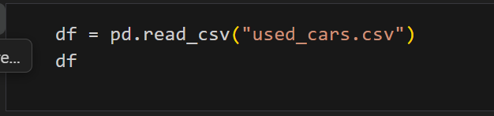
Explanation: This code cell loads libraries, reads dataset, or performs operations depending on its content.

Code Cell 3
df.head(2)
Explanation: This code cell loads libraries, reads dataset, or performs operations depending on its content.
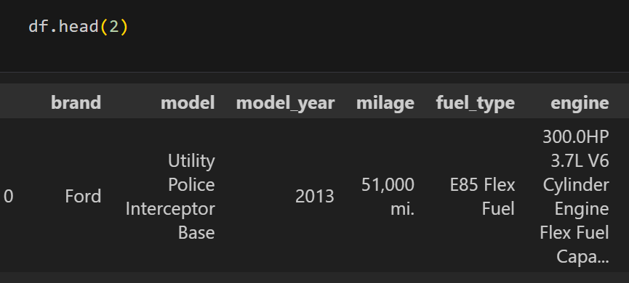

Code Cell 4
df.tail(2)
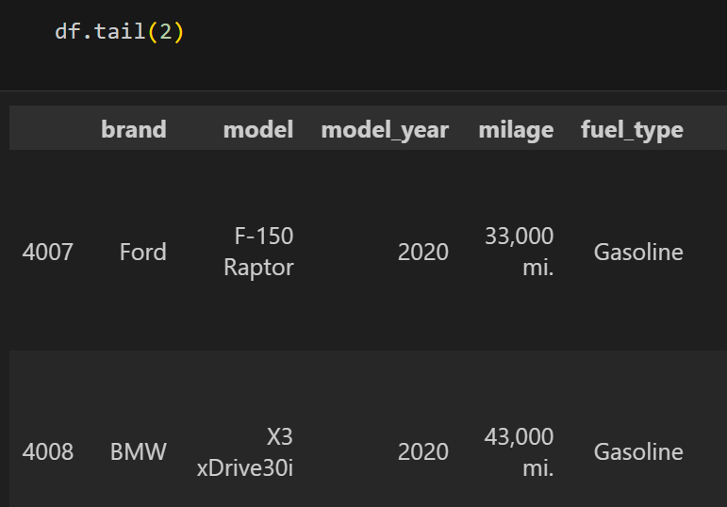
Explanation: This code cell loads libraries, reads dataset, or performs operations depending on its content.

Code Cell 5
df.columns
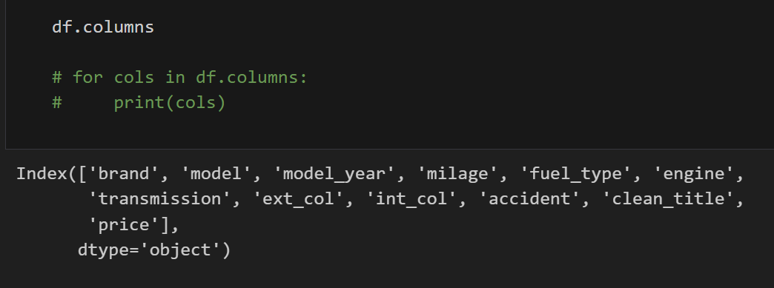
# for cols in df.columns:
# print(cols)
Explanation: This code cell loads libraries, reads dataset, or performs operations depending on its content.

Code Cell 6
df.count()
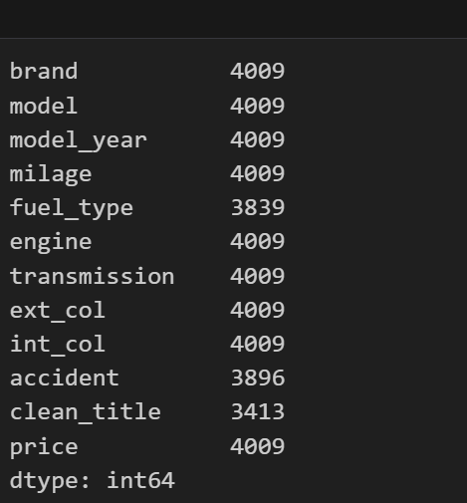
Explanation: This code cell loads libraries, reads dataset, or performs operations depending on its content.

Code Cell 7
df.describe()
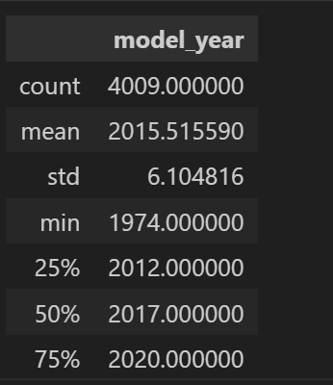
Explanation: This code cell loads libraries, reads dataset, or performs operations depending on its content.

Code Cell 8
df.info()
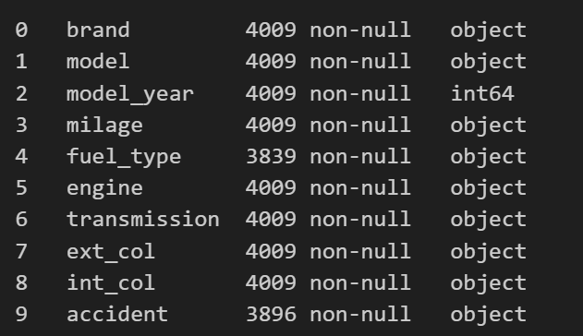
Explanation: This code cell loads libraries, reads dataset, or performs operations depending on its content.

Code Cell 9
df.shape()
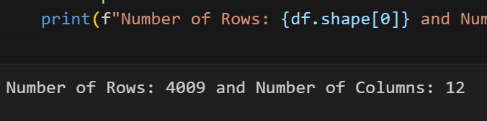
print(f"Number of Rows: {df.shape[0]} and Number of Columns: {df.shape[1]}")
Explanation: This code cell loads libraries, reads dataset, or performs operations depending on its content.

Code Cell 10
df['accident'].unique()
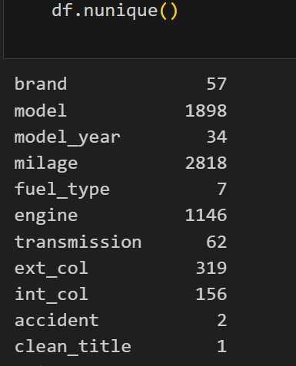
Explanation: This code cell loads libraries, reads dataset, or performs operations depending on its content.

Code Cell 11
df.nunique()
Explanation: This code cell loads libraries, reads dataset, or performs operations depending on its content.

Code Cell 12
df.isnull().sum()
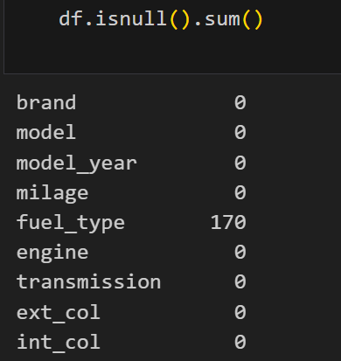
Explanation: This code cell loads libraries, reads dataset, or performs operations depending on its content.

Code Cell 13
# df.drop('date', axis=1, inplace=True)
df = df.drop('price', axis=1)
Explanation: This code cell loads libraries, reads dataset, or performs operations depending on its content.

Code Cell 14
df.info()
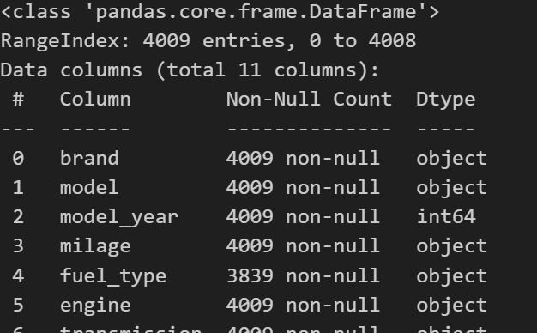
Explanation: This code cell loads libraries, reads dataset, or performs operations depending on its content.

Code Cell 15
df.head(2)
Explanation: This code cell loads libraries, reads dataset, or performs operations depending on its content.

Code Cell 16
df.to_csv('processed_data.csv', index=False, header=True)
Explanation: This code cell loads libraries, reads dataset, or performs operations depending on its content.

Code Cell 17
df = pd.read_csv('processed_data.csv')
df
Explanation: This code cell loads libraries, reads dataset, or performs operations depending on its content.

Code Cell 18
import pandas as pd
df = pd.read_csv('processed_data.csv')
# df.info()
df.columns
Explanation: This code cell loads libraries, reads dataset, or performs operations depending on its content.

Code Cell 19
X = df.drop('milage', axis=1) # Dependant columns / Input columns
y = df['milage'] # Resultant columns / Output column
Explanation: This code cell loads libraries, reads dataset, or performs operations depending on its content.

Code Cell 20
from sklearn.model_selection import train_test_split
train_X, test_X, train_y, test_y = train_test_split(X,y, test_size=0.3, shuffle=False) # 80:20, 70:30, 60:40
Explanation: This code cell loads libraries, reads dataset, or performs operations depending on its content.

Code Cell 21
print(train_X.shape, train_y.shape)
print(test_X.shape, test_y.shape)
Explanation: This code cell loads libraries, reads dataset, or performs operations depending on its content.

Code Cell 22
from sklearn.svm import SVC
from sklearn.model_selection import train_test_split
from sklearn.datasets import load_iris
data = load_iris()
X = data.data
y = data.target
train_X, test_X, train_y, test_y = train_test_split(X, y, test_size=0.2)
model_svc = SVC()
model_svc.fit(train_X, train_y)
print("Model Trained Successfully!")
Explanation: This code cell loads libraries, reads dataset, or performs operations depending on its content.

Code Cell 23
model_pred_svc = model_svc.predict(test_X)
model_pred_svc
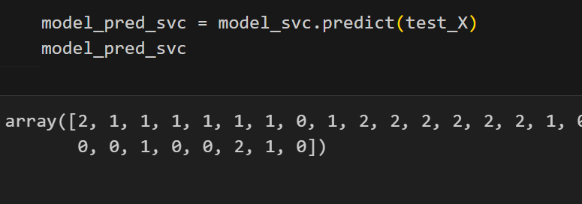
Explanation: This code cell loads libraries, reads dataset, or performs operations depending on its content.

Code Cell 24
from sklearn.metrics import accuracy_score
model_acc_svc = accuracy_score(test_y, model_pred_svc)
print(round(model_acc_svc,3)*100, "%")
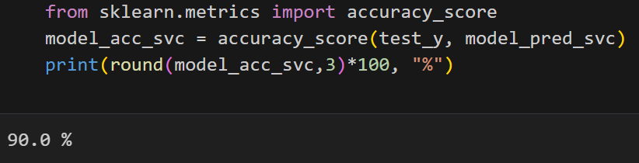
Explanation: This code cell loads libraries, reads dataset, or performs operations depending on its content.

Code Cell 25
import pickle
pickle.dump(model_svc, open('model_svc.pkl', 'wb')) # Model Saving
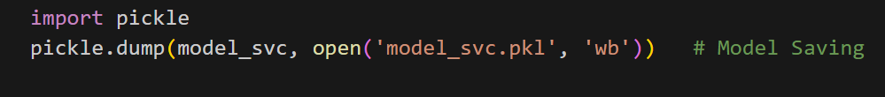
Explanation: This code cell loads libraries, reads dataset, or performs operations depending on its content.

Code Cell 26
import pickle
model_svc = pickle.load(open('model_svc.pkl', 'rb')) # Model Loading
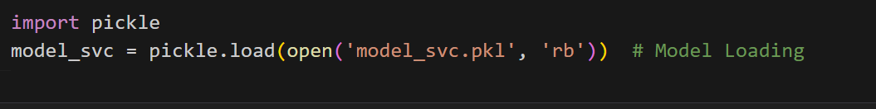
Explanation: This code cell loads libraries, reads dataset, or performs operations depending on its content.

Code Cell 27

Explanation: This code cell loads libraries, reads dataset, or performs operations depending on its content.

